StartHub Africa **UD Startup 101**

**Semester 2**

**Session 2**

StartHub Africa 

**Energizer**

www.starthubafrica.org

StartHub Africa 

**Objectives of today**

• Presentations of 5 people

• Journey of a startup

• Industry-Deep Dive

www.starthubafrica.org

StartHub Africa 

**The ideal Journey of a startup 1. Founder/Market Fit** – the basic setup

www.starthubafrica.org

StartHub Africa 

**The ideal Journey of a startup**

**1. Founder/Market Fit** – the basic setup

**2. Problem/Solution Fit** – Validate your MVP with a few clients

www.starthubafrica.org

StartHub Africa 

**The ideal Journey of a startup**

**1. Founder/Market Fit** – the basic setup

**2. Problem/Solution Fit** – Validate your MVP with a few clients **3. Break Even** – Build a base to hustle on from

www.starthubafrica.org

StartHub Africa 

**The ideal Journey of a startup**

**1. Founder/Market Fit** – the basic setup

**2. Problem/Solution Fit** – Validate your MVP with a few clients **3. Break Even** – Build a base to hustle on from

**4. 100 Customers who LOVE your product** – Build highest quality

www.starthubafrica.org

StartHub Africa 

**The ideal Journey of a startup**

**1. Founder/Market Fit** – the basic setup

**2. Problem/Solution Fit** – Validate your MVP with a few clients **3. Break Even** – Build a base to hustle on from

**4. 100 Customers who LOVE your product** – Build highest quality **5. Product/Market Fit** – Build something so good people talk about it

www.starthubafrica.org

StartHub Africa 

**The ideal Journey of a startup**

**1. Founder/Market Fit** – the basic setup

**2. Problem/Solution Fit** – Validate your MVP with a few clients **3. Break Even** – Build a base to hustle on from

**4. 100 Customers who LOVE your product** – Build highest quality **5. Product/Market Fit** – Build something so good people talk about it **6. Scale & Growth** – Build a team and scale what works

www.starthubafrica.org

StartHub Africa 

**EAC Case Study: Wena Hardware **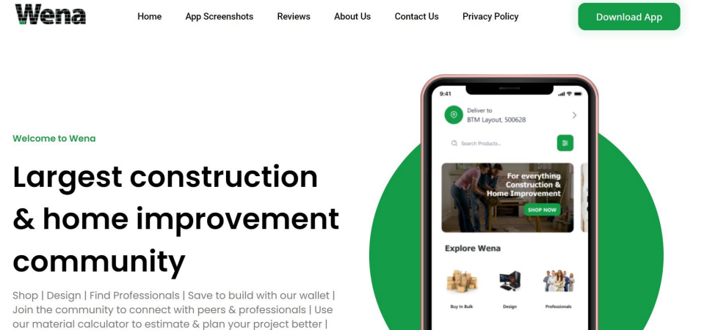

www.wenahardware.com

www.starthubafrica.org

StartHub Africa 

**Journey of Wena Hardware**

www.starthubafrica.org

StartHub Africa 

**Analyse Wenahardware’s story**

While listening to Vaola, note down

• Aspects of her journey that inspire you / you would do exactly like her

• Aspects of her journey you would do differently / you think she could have done better / faster etc.

www.starthubafrica.org

StartHub Africa 

**Getting unique**

**insights from**

**Industry**

StartHub Africa 

**What makes a**

**good idea?**

StartHub Africa 

**Recap: Signs of a good idea** 1. There is a Problem

2. The idea can grow big

3. You have a founder – market fit

4. You have a unique insight

5. You have a unique value proposition

www.starthubafrica.org

StartHub Africa 

**What makes a**

**good problem?**

StartHub Africa 

**Recap of a good problem**

1. It’s specific (ending poverty is not specific)

2. A lot of people have the problem / will have the problem 3. It’s urgent!

4. The problem costs people / companies a lot of money 5. Ideally a frequent problem

www.starthubafrica.org

StartHub Africa 

**How can you get unique insights?**

• Do cool internships

• Work with a startup

• Work with a company

• Work on projects

• Talk to knowledgeable people in specific industries

www.starthubafrica.org

StartHub Africa 

**How to use ChatGPT**

• Create an account on Open AI (https://openai.com/) • Use ChatGPT function and start asking questions

www.starthubafrica.org

StartHub Africa 

**Narrow down: Machinery**

We decided to speak to the Country Manager Tanzania of John Deere



www.starthubafrica.org

StartHub Africa 

**Questions we asked…**

1. Can you describe the agriculture ecosystem for us?

2. Where do you see business opportunities in the agriculture sector?

3. Where do you see untapped potentials? Why is no one tapping into it? 4. What would you do personally if your would go into agriculture?

5. Which other companies / startups in TZ or across the continent do you know who are already working on interesting problems?

www.starthubafrica.org

StartHub Africa 

**Cool Insights**

• A lot of production is not automated => rural farmers (80 %) farmers can’t afford proper equipment, they could afford them if they have cooperatives; Even when they can use equipment, they only buy the old ones, because they can only afford the old ones; => he thinks going into equipment is hard for a startup to produce on low cost with low units, competition is too big

• Cooperatives / units are missing: Farmers would be more productive if they farm as units

• Seeds: 80 % of seeds are imported from South Africa; a lot of GMO seeds, you can’t replant them; hardly anyone is growing seeds (only for flowers)

• Access to finance is a huge problem, because most of the farmers don’t meet the criteria to get funding

www.starthubafrica.org

StartHub Africa 

**More cool insights**

• Seasonal farming is not working out well; a lot of time of the year land is not used; could be opportunity

• Extension workers are missing who inform farmers about best practices etc. => Mode farms are missing

• Value addition (e.g. Habanero; in South Africa you sell the seeds and the outer skin separately); very few processing centres => we can dig deeper here and check which products are imported and what it would take to make them locally

www.starthubafrica.org

StartHub Africa 

**Interesting companies**

****www.starthubafrica.org

StartHub Africa 

**Dig Deeper**

What can we do to understand more why seeds are all imported? What can we do to understand issue of productive land use better?

www.starthubafrica.org

StartHub Africa 

**Group work until next week**

1. Final Goal: Identify one good problem and three potential business ideas 2. Use ChatGPT to get an understanding

3. Talk to min. 3 experts (find them through your networks, on LinkedIn etc.) 4. Dig deeper

5. Present 1 good problem (see criteria), who you spoke to, your unique insights, and three potential business ideas how to solve it

www.starthubafrica.org

StartHub Africa 

**Transport**

**Industry Deep**

**Dive**

**(TEMPLATE)**

StartHub Africa 

**The Transport industry landscape in Tanzania**

• Ask chatGPT for an overall overview

www.starthubafrica.org

StartHub Africa 

**Problems & Opportunities in Transport Sector in Tanzania**

www.starthubafrica.org

StartHub Africa 

**Successful transport startups across the region**

e.g. Sokowatch for transport and logistics

www.starthubafrica.org

StartHub Africa 

**Experts we spoke to** Pictures and why they are experts (min. 3)

www.starthubafrica.org

StartHub Africa 

**Unique insights we got**

www.starthubafrica.org

StartHub Africa 

**The specific problem**

• Why does the problem exist

• Break it down to the root cause through additional research (chatGPT, interviews)

www.starthubafrica.org

StartHub Africa 

**3 business opportunities we identified**

An opportunity includes the **specific product / service**, **who you sell to** and **how you make money.**

www.starthubafrica.org